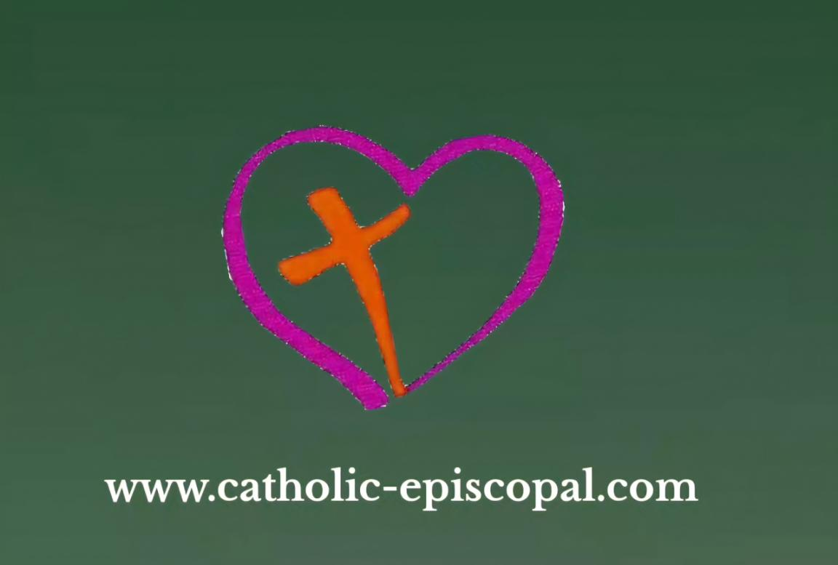

Thank you for choosing to explore the Path to Priesthood in Catholic Episcopal Church

To gain a better understanding of who we are and what we believe,
we have gathered together the answers to many Frequently Asked Questions
in the following link….

https://www.catholic-episcopal.com/general-7

Please take some time to have a read through the contents.

We recognise that the path to priesthood is unique and different for each individual.
When you reach out to us, we will be happy to discuss it with you.
Ours is a small church, and while we are spreading internationally, we are not a multi-million dollar global organisation; no-one receives a salary; all our Bishops, Priests and Deacons serve the church
on a voluntary basis, while seeking an alternative source of income.
We do not currently have a Seminary and we are unable to provide any financial assistance for studies.

Before you contact us, please gather together the following items,
which will help in our mutual discussions and deliberations.

- A copy of your Curriculum Vitae, with any pastoral experience in a faith environment.
- A History of your Educational Achievements & Qualifications
- A short history of your life, giving us a picture of who you are and your journey in faith.
- Any other information which might help us to consider your application

If you are an existing Priest or Pastor of another denomination and wish to seek Incardination,
Please also include

- Contact details of your previous church leadership
- A history of your previous church ministry
- Copies of any Ordination Certficates

All Candidates will be required to provide at least three references from people who know you well.

Please make intial contact to

Rev Seamus (in English)
catholic-episcopal@gmail.com

Rev Jesus Pinya (en Espanol)
jesuspinya@yahoo.es

